

**King Fahd University of Petroleum and Minerals**

**Information and Computer Science Department**

**ICS 324**

**Term 143**

**Phase 1: Conceptual and Logical Design**

|  |  |
| --- | --- |
| Member | ID |
| Ibrahim | 201139750 |
| Ibrahim | 201224780 |
| Aqeel | 201236760 |

Table of Contents

1. Problem Statement 2

2. Assumptions 2

3. Database Requirements (defines the entities, attributes, relationships and constraints). 2

4. Conceptual schema (ER/EER Model) 3

5. Relational schema (all relations and constraints) 3

6. DDL statements to create database tables 4

# Problem Statement

We have to design and implement a database that can be used by academic institutions to record the grades of students in specific course. To design this, we have to consider 3 main actors: student, instructor and a course. Each of those will affect the final product.

# Assumptions

* 1. We will assume that the database will be made for KFUPM use.
  2. We will assume that the length of names will not exceed 15 characters.
  3. We will assume that the condition on delete will be ‘set null’.
  4. Assume that each course will have at least 2 grading component.
  5. Assume that the number of grading component for all courses won’t exceed 1000.
  6. Assume that each college and department has an alphabetic unique ID that represents it.
  7. Assume that the section reference number will be formed as follows: College ID + Department ID + course number + term number + section number.
  8. Assume that every year the section reference number is recycled.
  9. Each section will be taught by one instructor.
  10. Assume that the sum of all points on a section can be less than 100 or more.

# Database Requirements (defines the entities, attributes, relationships and constraints).

We can summarize the database requirements as follows:

1. Students’ first and last names and majors shall be recorded and be identified with a unique student id
2. Courses’ number shall be recorded and it shall be identified with a unique course id
3. Each section must belong to a course in a specific term and shall be identified by a unique section number and taught by an instructor
4. The section is made up from several grading components where each has a maximum points and an overall weight
5. Sections must have enrolled students
6. The instructor will be able to record points for students
7. Instructors shall be able to assign letter grades and grade cutoffs for each of his section

# Conceptual schema (ER/EER Model)

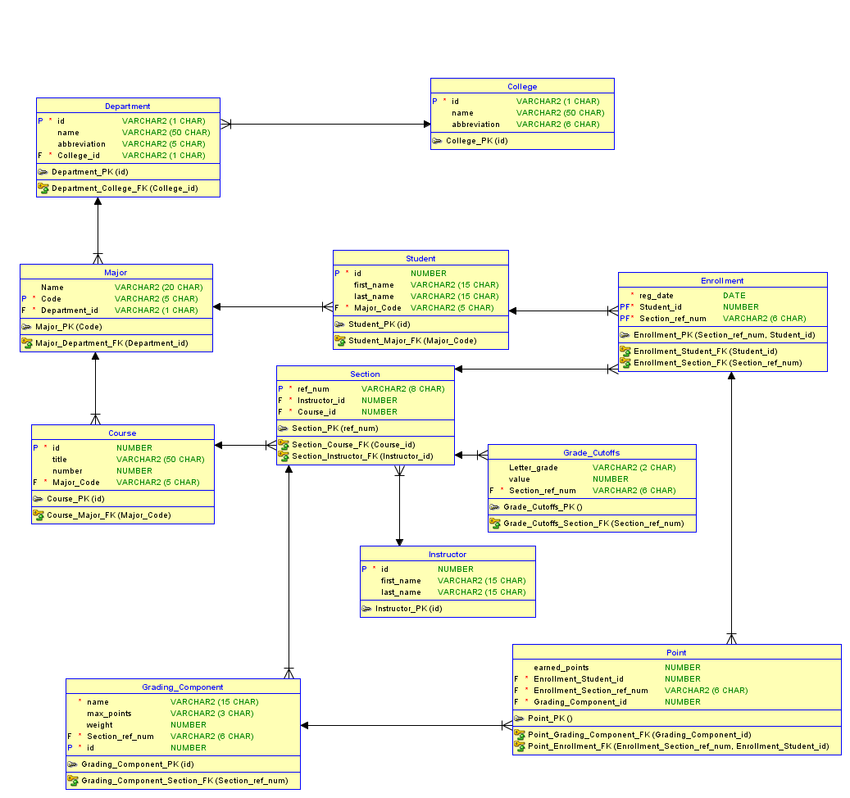

# Relational schema (all relations and constraints)

# DDL statements to create database tables

CREATE TABLE College

(

id VARCHAR2 (1 CHAR) NOT NULL ,

name VARCHAR2 (50 CHAR) ,

abbreviation VARCHAR2 (6 CHAR)

) ;

ALTER TABLE College ADD CONSTRAINT College_PK PRIMARY KEY ( id ) ;

CREATE TABLE Course

(

id NUMBER NOT NULL ,

title VARCHAR2 (50 CHAR) ,

"number" NUMBER ,

Major_Code VARCHAR2 (5 CHAR) NOT NULL

) ;

ALTER TABLE Course ADD CONSTRAINT Course_PK PRIMARY KEY ( id ) ;

CREATE TABLE Department

(

id VARCHAR2 (1 CHAR) NOT NULL ,

name VARCHAR2 (50 CHAR) ,

abbreviation VARCHAR2 (5 CHAR) ,

College_id VARCHAR2 (1 CHAR) NOT NULL

) ;

ALTER TABLE Department ADD CONSTRAINT Department_PK PRIMARY KEY ( id ) ;

CREATE TABLE Enrollment

(

reg_date DATE NOT NULL ,

Student_id NUMBER NOT NULL ,

Section_ref_num VARCHAR2 (6 CHAR) NOT NULL

) ;

ALTER TABLE Enrollment ADD CONSTRAINT Enrollment_PK PRIMARY KEY ( Section_ref_num, Student_id ) ;

CREATE TABLE Grade_Cutoffs

(

Letter_grade VARCHAR2 (2 CHAR) ,

value NUMBER ,

Section_ref_num VARCHAR2 (6 CHAR) NOT NULL

) ;

CREATE TABLE Grading_Component

(

name VARCHAR2 (15 CHAR) NOT NULL ,

max_points VARCHAR2 (3 CHAR) ,

weight NUMBER ,

Section_ref_num VARCHAR2 (6 CHAR) NOT NULL ,

id NUMBER NOT NULL

) ;

ALTER TABLE Grading_Component ADD CONSTRAINT Grading_Component_PK PRIMARY KEY ( id ) ;

CREATE TABLE Instructor

(

id NUMBER NOT NULL ,

first_name VARCHAR2 (15 CHAR) ,

last_name VARCHAR2 (15 CHAR)

) ;

ALTER TABLE Instructor ADD CONSTRAINT Instructor_PK PRIMARY KEY ( id ) ;

CREATE TABLE Major

(

Name VARCHAR2 (20 CHAR) ,

Code VARCHAR2 (5 CHAR) NOT NULL ,

Department_id VARCHAR2 (1 CHAR) NOT NULL

) ;

ALTER TABLE Major ADD CONSTRAINT Major_PK PRIMARY KEY ( Code ) ;

CREATE TABLE Point

(

earned_points NUMBER ,

Enrollment_Student_id NUMBER NOT NULL ,

Enrollment_Section_ref_num VARCHAR2 (6 CHAR) NOT NULL ,

Grading_Component_id NUMBER NOT NULL

) ;

CREATE TABLE Section

(

ref_num VARCHAR2 (8 CHAR) NOT NULL ,

Instructor_id NUMBER NOT NULL ,

Course_id NUMBER NOT NULL

) ;

ALTER TABLE Section ADD CONSTRAINT Section_PK PRIMARY KEY ( ref_num ) ;

CREATE TABLE Student

(

id NUMBER NOT NULL ,

first_name VARCHAR2 (15 CHAR) ,

last_name VARCHAR2 (15 CHAR) ,

Major_Code VARCHAR2 (5 CHAR) NOT NULL

) ;

ALTER TABLE Student ADD CONSTRAINT Student_PK PRIMARY KEY ( id ) ;

ALTER TABLE Course ADD CONSTRAINT Course_Major_FK FOREIGN KEY ( Major_Code ) REFERENCES Major ( Code ) ;

ALTER TABLE Department ADD CONSTRAINT Department_College_FK FOREIGN KEY ( College_id ) REFERENCES College ( id ) ;

ALTER TABLE Enrollment ADD CONSTRAINT Enrollment_Section_FK FOREIGN KEY ( Section_ref_num ) REFERENCES Section ( ref_num ) ;

ALTER TABLE Enrollment ADD CONSTRAINT Enrollment_Student_FK FOREIGN KEY ( Student_id ) REFERENCES Student ( id ) ;

ALTER TABLE Grade_Cutoffs ADD CONSTRAINT Grade_Cutoffs_Section_FK FOREIGN KEY ( Section_ref_num ) REFERENCES Section ( ref_num ) ;

ALTER TABLE Grading_Component ADD CONSTRAINT Grading_Component_Section_FK FOREIGN KEY ( Section_ref_num ) REFERENCES Section ( ref_num ) ;

ALTER TABLE Major ADD CONSTRAINT Major_Department_FK FOREIGN KEY ( Department_id ) REFERENCES Department ( id ) ;

ALTER TABLE Point ADD CONSTRAINT Point_Enrollment_FK FOREIGN KEY ( Enrollment_Section_ref_num, Enrollment_Student_id ) REFERENCES Enrollment ( Section_ref_num, Student_id ) ;

ALTER TABLE Point ADD CONSTRAINT Point_Grading_Component_FK FOREIGN KEY ( Grading_Component_id ) REFERENCES Grading_Component ( id ) ;

ALTER TABLE Section ADD CONSTRAINT Section_Course_FK FOREIGN KEY ( Course_id ) REFERENCES Course ( id ) ;

ALTER TABLE Section ADD CONSTRAINT Section_Instructor_FK FOREIGN KEY ( Instructor_id ) REFERENCES Instructor ( id ) ;

ALTER TABLE Student ADD CONSTRAINT Student_Major_FK FOREIGN KEY ( Major_Code ) REFERENCES Major ( Code ) ;